M.P.BHANUSHREE

192111041

ITA 1478- Ethical Hacking for Mobile Applications

1.Information gathering using the harvester

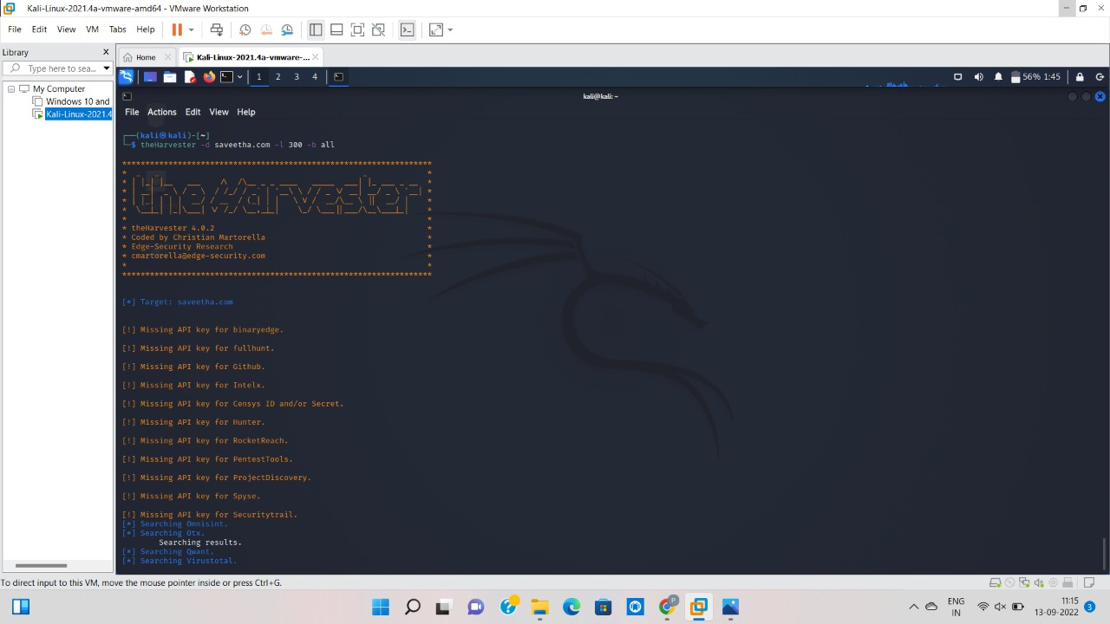

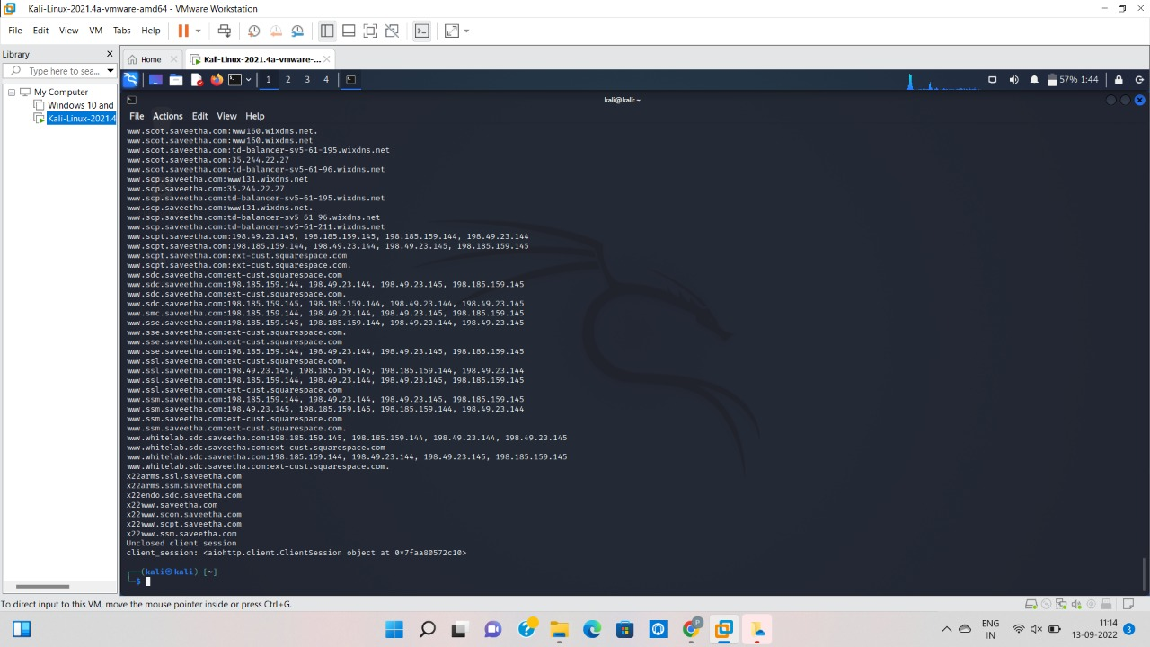

2.Open source intelligence gathering using OSRFramework

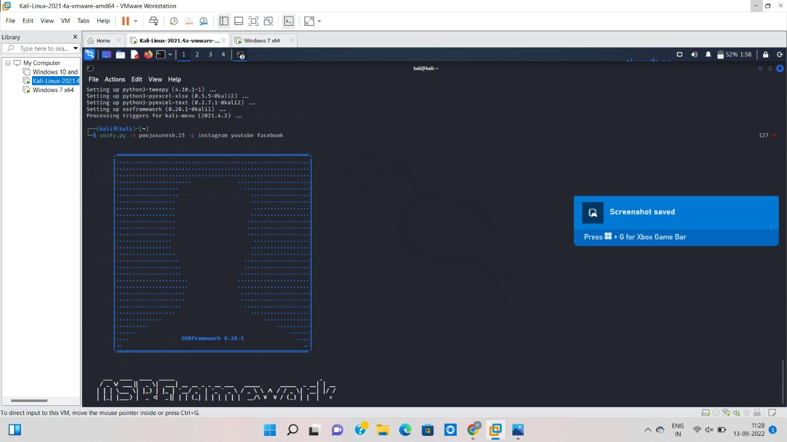

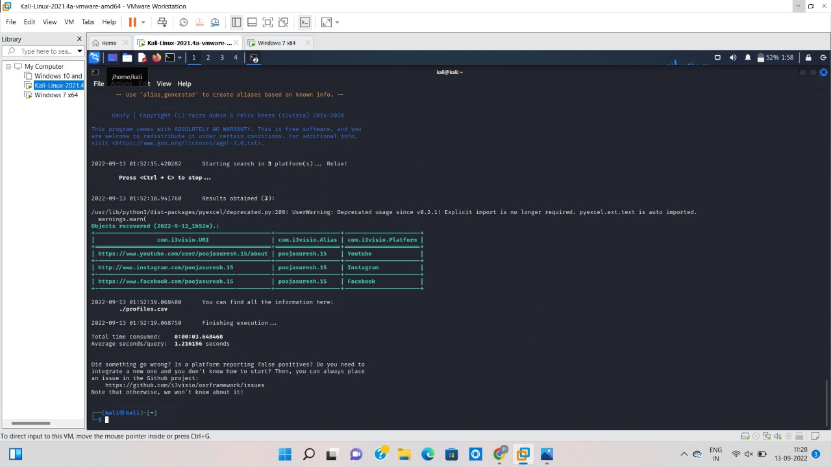

3.USE GOOGLE AND WHOIS FOR RECONNAISANCE

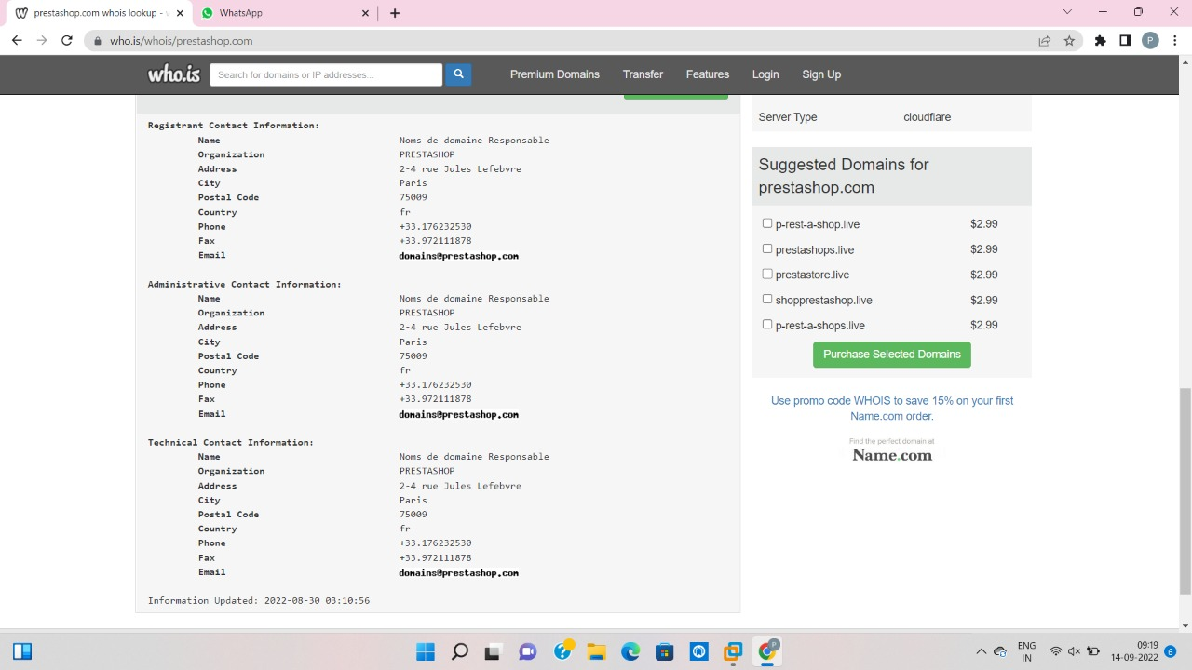

4.Using traceroute, ping, ifconfig, netstat command

